**WEEK 6: Assignment**

1. For the following graphs state the relationship w.r.t. subdivision and an elementary subdivision.

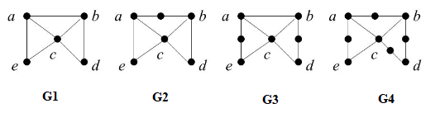

Answer: A subdivision of a graph G is a graph obtained from G by a sequence of zero or more elementary subdivisions. Therefore; G1 is a subdivision of itself, followed by:

* Graph G4 is a subdivision of Graph G3,G2,G1,whereas it is elementary subdivision of graph G3.
* Graph G3 is a subdivision of Graph G2,G1,whereas it is elementary subdivision of graph G2.
* Graph G2 is a subdivision of Graph G1 and elementary subdivision of graph G1.

1. “Every non-planar graph is a planar graph.” State whether the statement is true or false.

Justify your answer with appropriate example.

Answer: False, A graph is non-planar if and only if it contains a subgraph homeomorphic to K5 or K3,3. A graph is said to be planar if it can be drawn in a plane so that no edge cross.  A planar graph divides the plans into one or more regions. One of these regions will be infinite. So; Every non-planar graph is a planar graph is a false statement.

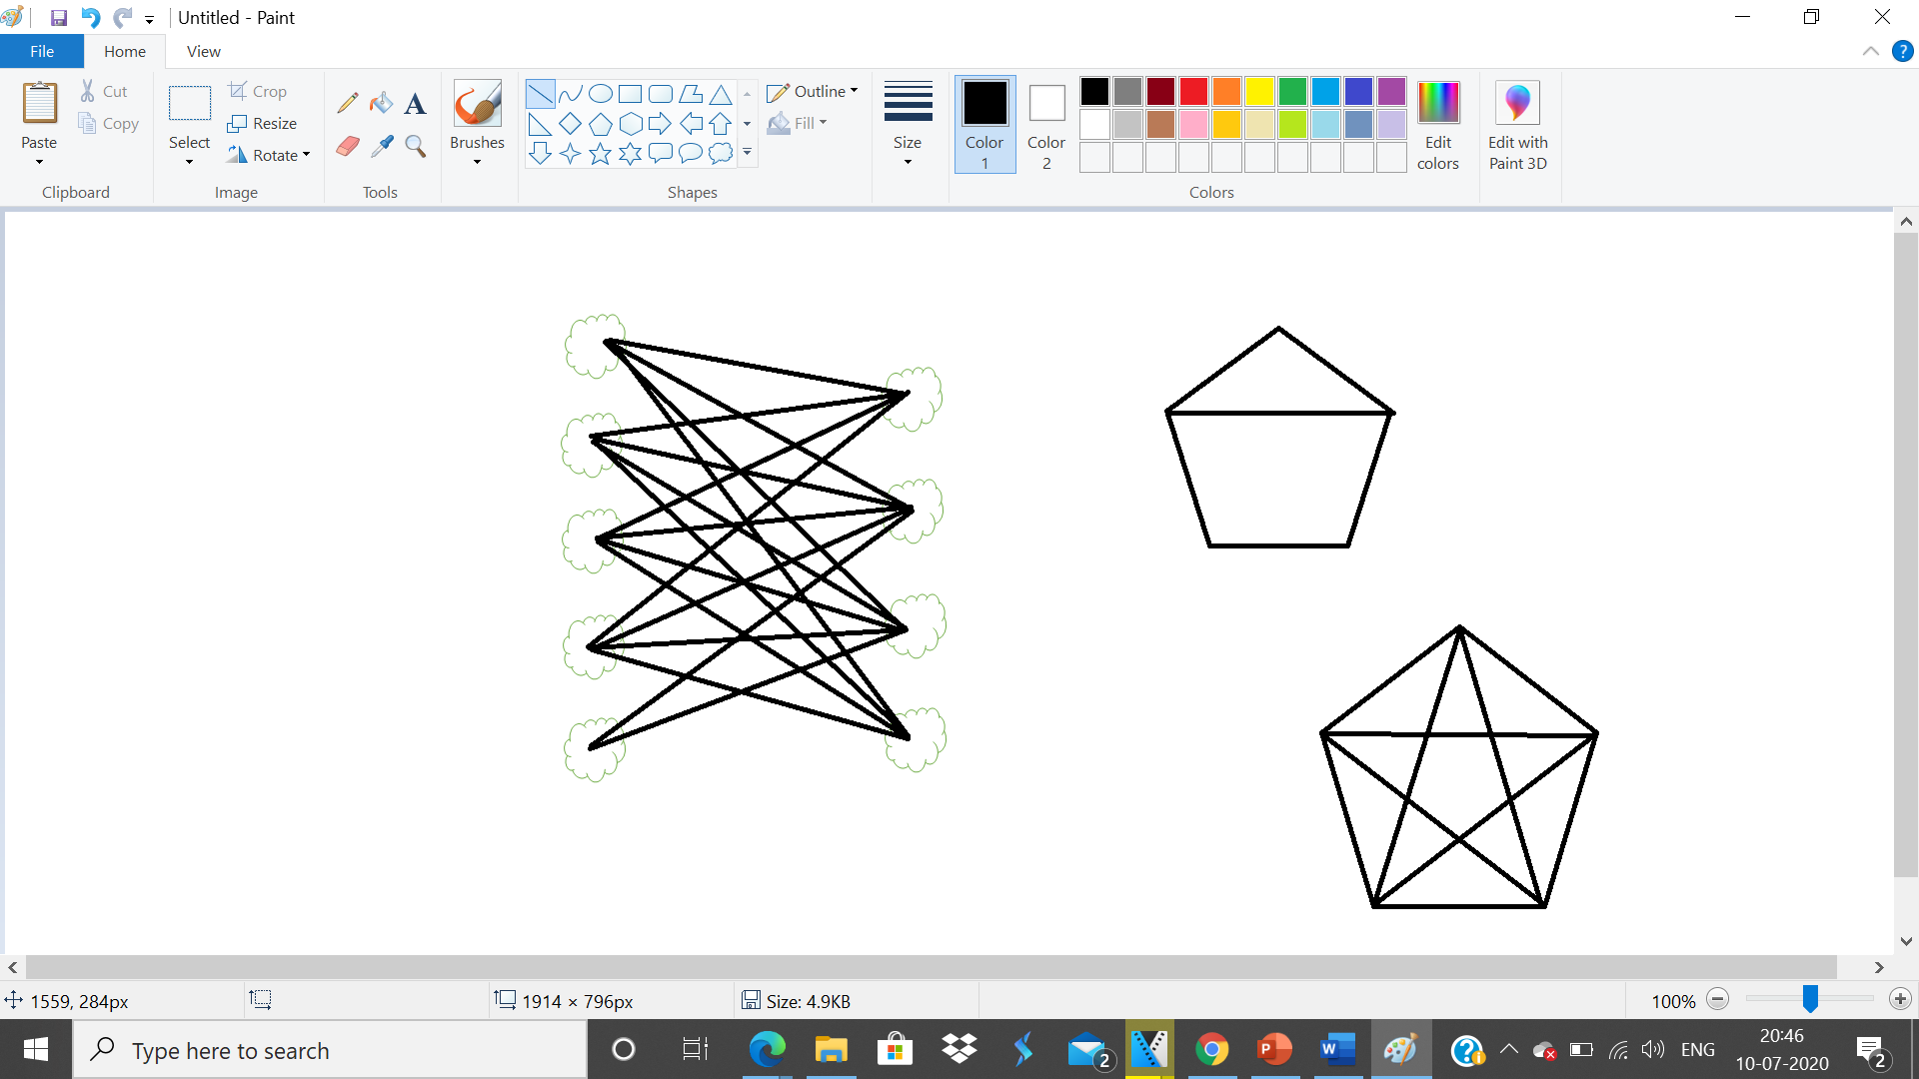 

‘A’ ‘B’

‘A’ = Planar Graph

‘B’= Non Planar Graph

1. “Every planar graph is a maximal planar graph.” State whether the statement is true or false. Justify your answer with appropriate example.

Answer: False, Every planar graph can not be maximal planar graph unless until we join the edges or unless until we add some extra edges maintaining its property .i.e its planar property. Any plane graph is called as maximal plane graph if you can add edges to the graph maintaining its property of being planar.

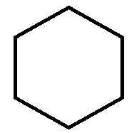

‘A’

The boundary of all the regions in the Graph ‘A’ below has a triangle, thus this property is also called as Triangulation.Similarly, the maximum planar graph of the following hexagon can be obtained by adding six edges to the graph maintaining the planarity of it. There are 8 regions - 7 bounded region and 1 exterior region, which are all triangle. Thus, follow the property of Triangulation.

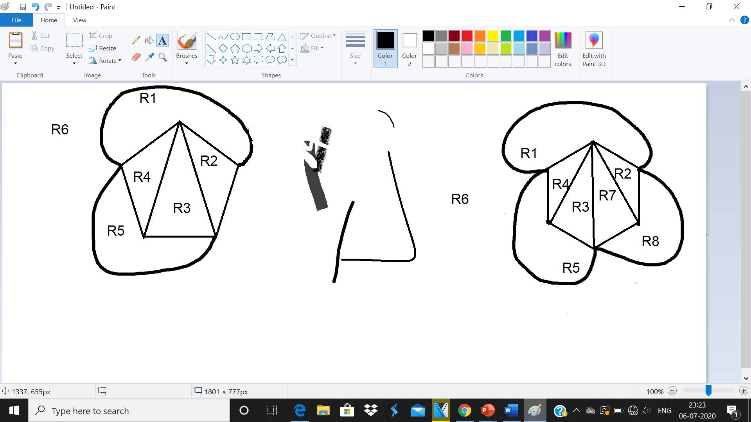

1. If there is a bipartite graph with 4 and 5 set of vertices in its partition respectively with 18 edges. Determine whether the graph is a planar graph. Draw appropriate diagram as well.

Answer: As we know that not each and every graph is a planar graph. So incase if there are n number of edges and a not many vertices compared to edges, then already some of the edges will intersect. Example: K5 graph. So; speaking about K5 graph it has 4 and 5 vertices and 18 edges, so we get K4,5. Using the formula we can determine whether the graph is a planar graph or not:

Formula:

m=3n-6

m=2n-4

Given:

m=18

n=9

Solution:

18=2*9-4

18=18-4

18=14

So 18 is not equal to 14 so it is a non- planar graph.

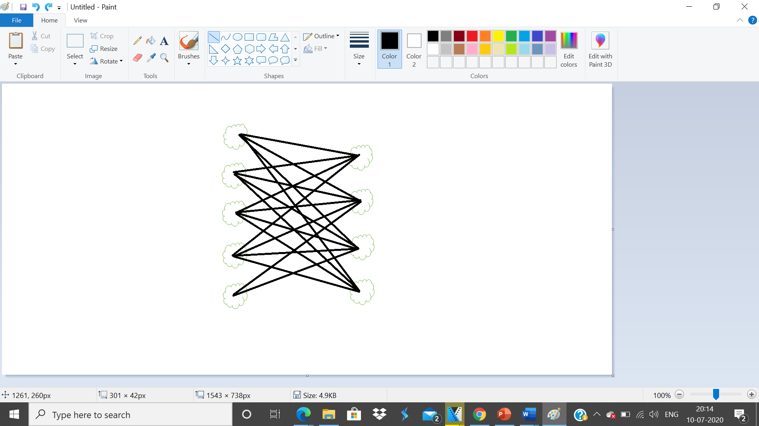

1. What will the number of regions if the following graph is a maximal planar graph?

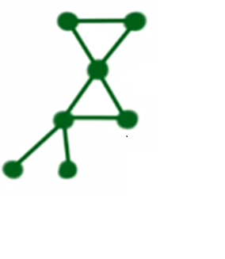

Answer: Any graph will be said to be maximal planar graph only if you can add edges to the graph maintaining its property .i.e. being planar.

So; total number of edges will be:

=3n-6

=3(7)-6

=21-6

=15

So; we know that E=15 ; now it will be easy to find the number of regions if the following graph is a maximal planar graph with the formula:

R=e-v+2

R=15-7+2

R=10

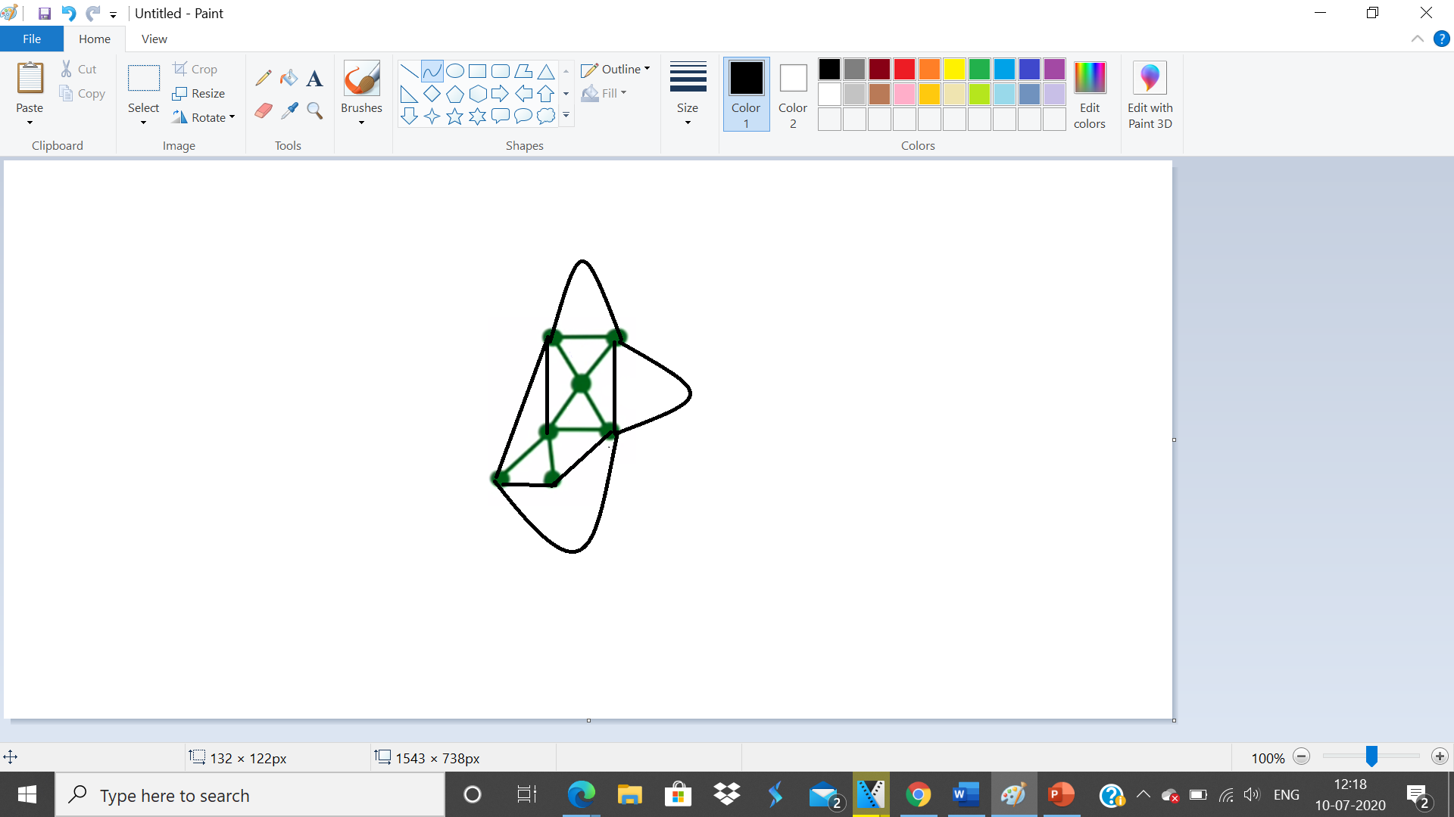

1. Which of the following statements are false for the following graph? Justify your answer with appropriate definitions.



Statement 1: The graph is a complete graph.

Answer: True, it is a complete graph with K2 .i.e. 2 vertices. A complete graph is nothing but every node should be connected to all other node ; in a complete graph every node is adjacent to all other nodes in graph.

Statement 2: The graph is a complete bipartite graph.

Answer: True, bipartite graph is a graph in which a set of graph vertices can be divided into two independent sets, and no two graph vertices within the same set are adjacent.

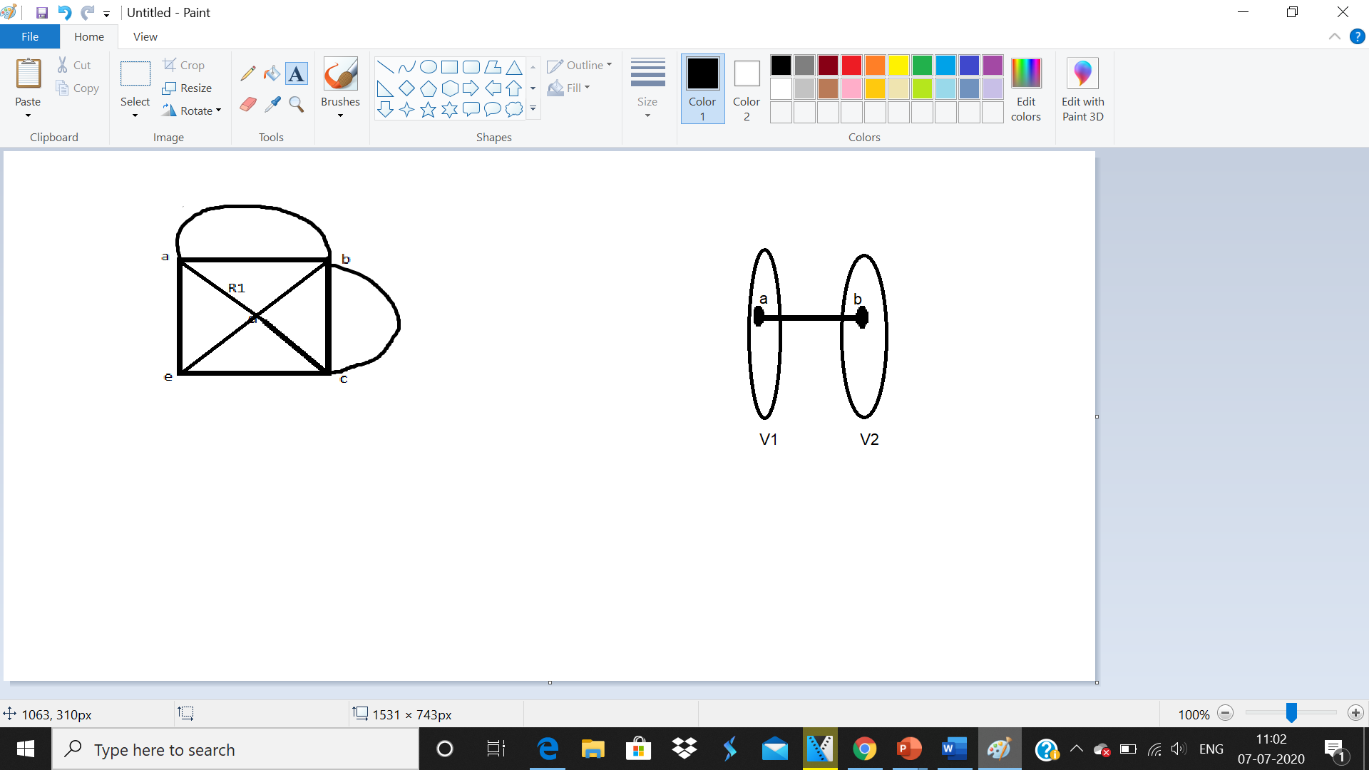

Statement 3: The graph is not a bipartite graph.

Answer: False.

Statement 4: The graph is a connected graph.

Answer: True. Here is a path from any point to any other point in the **graph which is connected.** A **graph** that is not **connected** is said to be disconnected.